Nwes MENTORING AGREEMENT 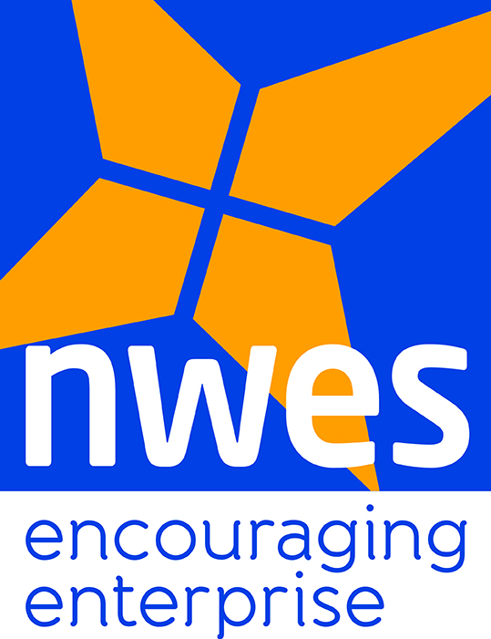

Thank you for becoming an Nwes Mentor. The purpose of this agreement is to outline the broad terms on which you, as a Mentor, engage with Nwes clients who are looking for mentoring support as they start or grow their businesses (the Mentee). These statements are designed to guide the relationship – any specific issues or difficulties should be discussed immediately with Nwes or email info@nwes.org.uk

Please read and sign below to indicate that you agree with the following statements:

✓ At all times operate within the limits of your own competence and if necessary refer clients to other professional business/financial advisors/Nwes if the client is seeking support beyond the scope of your own skills, knowledge and experience.
✓ Make suggestions but never impose advice on a client, nor act on their behalf nor complete documents for them and make it absolutely clear that any final decisions must be made by the Mentee.
✓ Refrain from offering professional advice or information that may be confidential to others, misleading or where it is not possible to assess its accuracy.
✓ Never offer financial advice including advice about loans that have been received by the client or other advice they may be regulated by other legislation.
✓ Respect all copyrights, agreements, work, intellectual property and trademarks belonging to Mentee and comply with laws covering such areas.
✓ Be aware of the potential for conflicts of interest of either a commercial or emotional nature to arise through the mentoring relationship and deal with them quickly and effectively to ensure there is no detriment to the Mentee.
✓ Not accept payment of any kind or profit individually from the mentoring interaction, or from interaction with the Mentee or Mentee’s businesses outside of the mentoring interaction
✓ Not exploit the relationship with the Mentee in any manner, including, but not limited to, financial, sexual or other matters that might exist beyond a professional relationship.
✓ Respect confidentiality and never disclose information only where explicitly agreed in writing by the Mentee (unless the Mentor believes that there is convincing evidence of serious risk, danger or unlawfulness to the Mentee or others if the information is withheld).
✓ Obtain written permission from the Mentee and Nwes before releasing Mentee names as referees.
✓ Ensure Nwes is copied reports of any meetings or significant conversations with the Mentee.

Nwes Mentors understand that their professional responsibilities continue beyond the termination of any mentoring relationship. These include the following:

✓ Maintenance of confidentiality of all information relating to clients and Nwes.
✓ Avoidance of any exploitation (financial or otherwise) of the former relationship.
✓ Provision of any follow-up which has been agreed.
✓ Safe and secure maintenance of all related records and data.

Signed: Name:
Date:

Updated 16 November 2016

