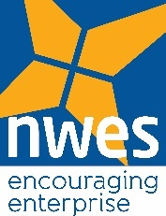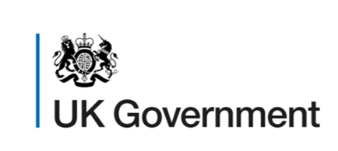

We require an Administrative Assistant on a flexible basis to work within our Business Enterprise Team to deliver our Enabling Self-employment programmes. The support is required from 1st July 202 to 30th September 2022 with the possibility of further support required to 31st December 2022.

This project is part-funded by the UK Government through the UK Community Renewal Fund.

The Role
You will be the friendly voice that greets our clients with their enquiries, you will advise them on our support packages and book appointments with our advisors and trainers. You will take ownership of client paperwork and work with all the team to support the clients journey ensuring we are compliant with programme requirements whilst keeping our company CRM up to date.

You will have a friendly personality and positive attitude towards your work and our clients as we take pride in offering first class customer service. Can get your work done without too much supervision and thrive on the challenges that a small business environment brings.

We anticipate our support requirements will fluctuate on a week-by-week basis but will typically, when required, be for at least a half day (4 hours). Our requirement will depend on client volumes which are difficult to predict. We are flexible what hours you work between, but we would like this to include weekend working on a regular basis.

Due to the uncertainty of the hours, we are open to the position being fulfilled on a self-employed basis by an individual or by an organisation.

Main Duties and Responsibilities In the role you will:
- Communicate clearly with clients, including responding to telephone, email and texts
- Make outbound calls to follow up on client’s progress
- Enter and maintain customer information on our and funders databases
- Work alongside our trainers and advisors to manage the client journey with contractual paperwork

Person Specification
- Align with our business mission and want to be part of the team that deliver this to our clients
- Be driven to always deliver the best customer experience possible
- Be friendly, have a good sense of humour and be a good communicator, a positive and proactive attitude is essential
- Be Structured and organised
- Have an interest in administrative tasks and be a perfectionist when it comes to attention to detail
- Be a team player and contribute to effective team working
- Be able to work to time-based deadlines and manage multiple activities
- Be competent with Microsoft office, data entry, email and websites

This role can either be office based in either King’s Lynn or Norwich or we can offer hybrid working by exception

Our Purpose

Encouraging Enterprise - To help entrepreneurs navigate the path to business success by providing services of real value, delivered with unrivalled customer service

Our Mission
We deliver real impact to entrepreneurs, supporting them every step of their journey. We believe that anyone can become an entrepreneur and those who choose that path should be given the best chance, regardless of background. We empower entrepreneurs to realise their ambitions.

We enjoy sharing our knowledge but never stop learning ourselves. We are not afraid to do things differently.

Applications
To apply please send a covering email explaining why you and/or your organisation are well suited to the role, along with your CV(s) to advance@nwes.org.uk and quote your daily rate

Closing Date for responses: 8th July 2022

